**Flutter App Development Course**

**DAY # 2**

**Task 1:**

**Source Code:**

import 'package:flutter/material.dart';

void main() {

runApp(MyApp());

}

class MyApp extends StatelessWidget {

// This widget is the root of your application.

@override

Widget build(BuildContext context) {

return MaterialApp(

debugShowCheckedModeBanner: false,

home: Scaffold(

backgroundColor: Colors.black,

body: Center(child: Container( height: 100, width: 100,

child: Image.asset("assets/Dart.png",))),

)

);

}

}

**OUTPUT:**

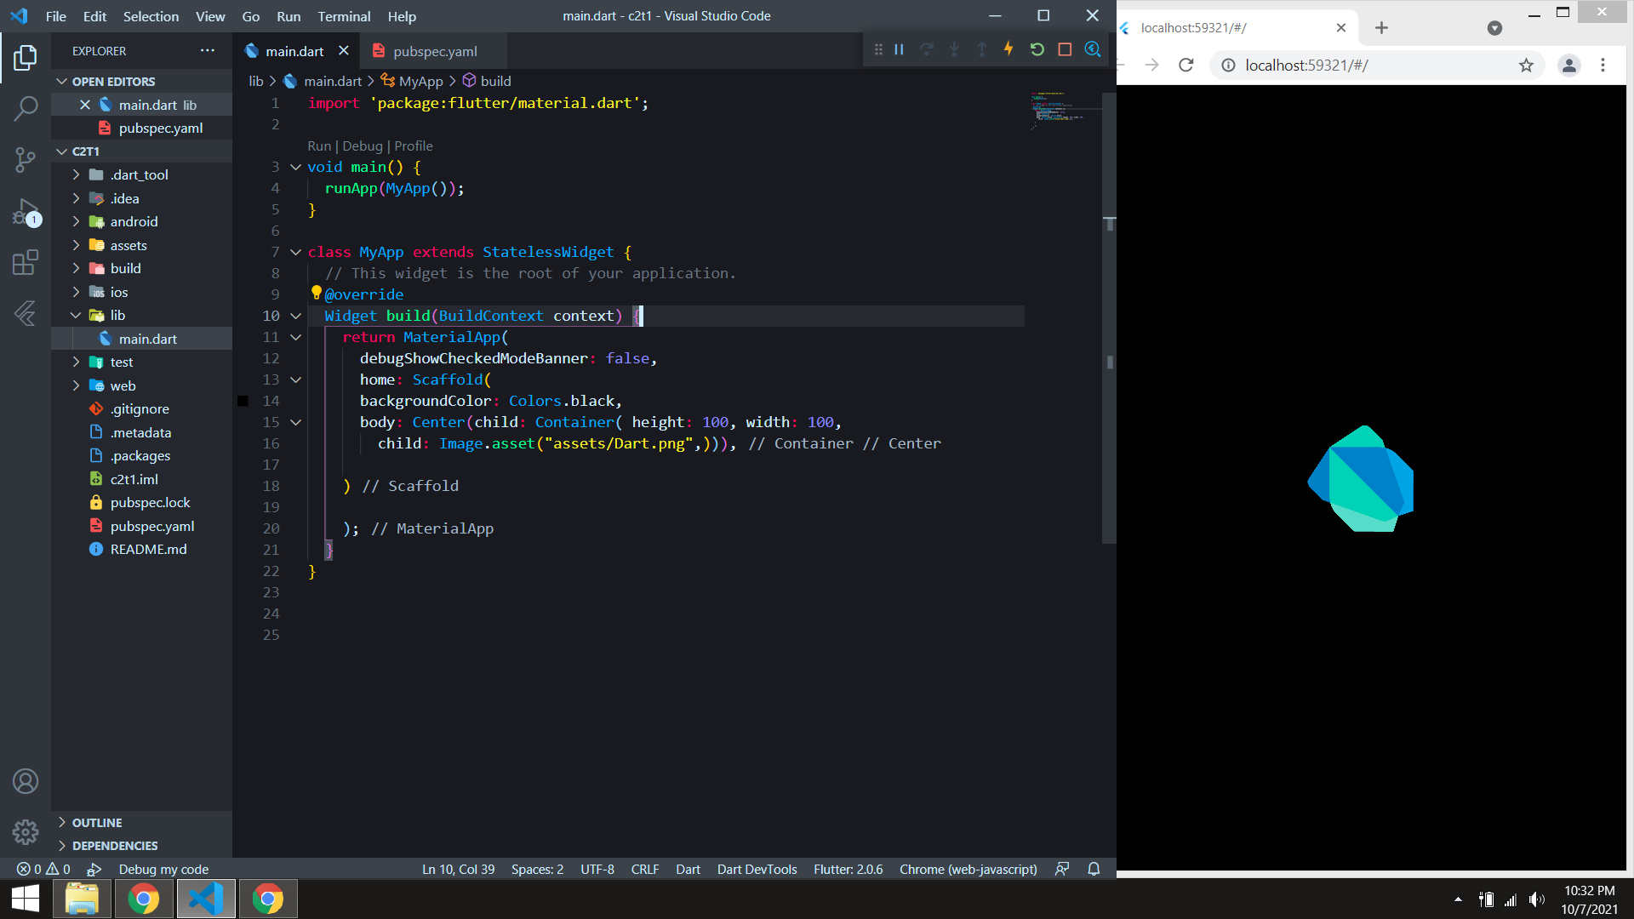

**Task 2:**

**Source Code:**

import 'dart:ui';

import 'package:flutter/material.dart';

void main() {

runApp(MyApp());

}

class MyApp extends StatelessWidget {

// This widget is the root of your application.

@override

Widget build(BuildContext context) {

return MaterialApp(

debugShowCheckedModeBanner: false,

home: Scaffold(

backgroundColor: Colors.cyan[900],

body: Column(

// mainAxisAlignment: MainAxisAlignment.center,

children: [

Padding(

padding: const EdgeInsets.only(top:198.0),

child: Center(child: CircleAvatar(

backgroundColor: Colors.white60, radius: 46,

// CIRCLE AVATAR

child: CircleAvatar(

backgroundImage: AssetImage("assets/Pic2ED2.jpg"),

radius: 44,

),

),

),

),

Padding(

padding: const EdgeInsets.only(bottom :6.0,top: 15),

child: Text("Shahab Alam ",style: TextStyle(color: Colors.grey[300], fontSize: 24 , fontWeight: FontWeight.bold)),

),

Padding(

padding: const EdgeInsets.only(bottom :6.0,top: 5),

child: Text("FLUTTER DEVELOPER ",style: TextStyle(color: Colors.grey[500],letterSpacing: 3 , fontSize: 18 , fontWeight: FontWeight.bold)),

),

Container(height: 2, width: 150, color: Colors.white12, margin: EdgeInsets.only(top:15),),

Container( height: 40, width: 330, color: Colors.white24, margin: EdgeInsets.only(top: 45),

child: Row(

// mainAxisAlignment: MainAxisAlignment.spaceAround,

children: [

Padding(

padding: const EdgeInsets.only(left:18.0),

child: Icon(Icons.phone,color:Colors.black ,),

),

Padding(

padding: const EdgeInsets.only(left:18.0),

child: Text("+92 341-275-7081", style: TextStyle(fontWeight: FontWeight.bold ,fontSize: 18 ,color: Colors.grey[800]),)),

],

),),

Container( height: 40, width: 330, color: Colors.white24, margin: EdgeInsets.only(top: 18),

child: Row(

// mainAxisAlignment: MainAxisAlignment.spaceAround,

children: [

Padding(

padding: const EdgeInsets.only(left:18.0),

child: Icon(Icons.email ,color:Colors.black ,),

),

Padding(

padding: const EdgeInsets.only(left:18.0),

child: Text("IamShahabAlam@gmail.com", style: TextStyle(fontWeight: FontWeight.bold ,fontSize: 18 ,color: Colors.grey[800]),)),

],

),)

],

),

)

);

}

}

**OUTPUT:**

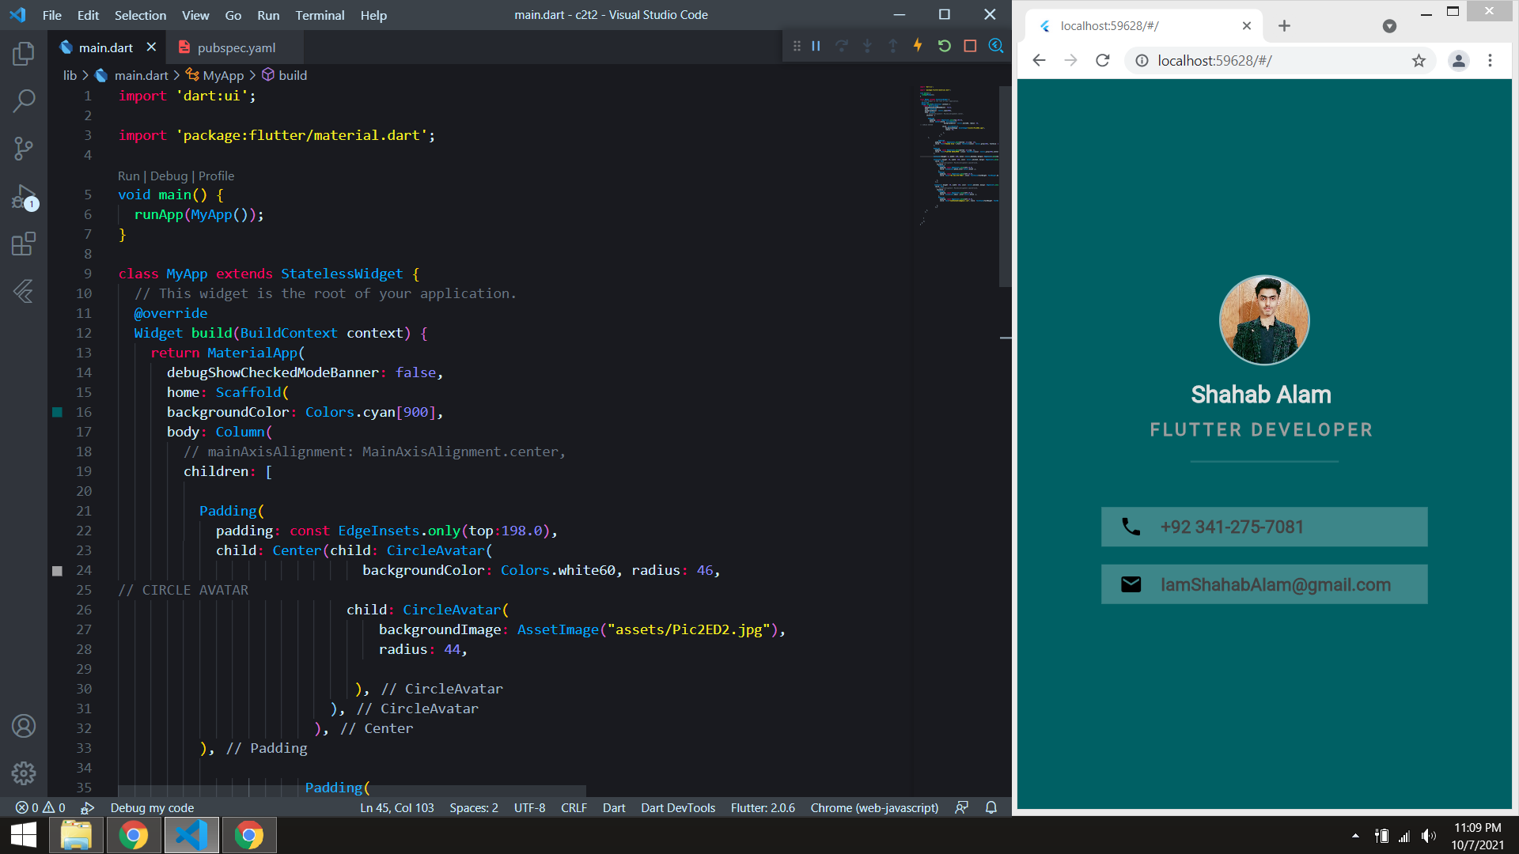

**Task 3:**

**Source Code:**

import 'package:flutter/material.dart';

void main() {

runApp(MyApp());

}

class MyApp extends StatelessWidget {

// This widget is the root of your application.

@override

Widget build(BuildContext context) {

return MaterialApp(

debugShowCheckedModeBanner: false,

home: Scaffold(

backgroundColor: Colors.green[50],

body: Column(

children: [

Padding(

padding: const EdgeInsets.only(top :100.0),

child: Center(child: Image.network("assets/SC.png",height: 140, width: 140,) ),

),

Container( padding: EdgeInsets.only(top:30),

child: Text("SHAHAB's STORE", style: TextStyle(fontSize: 24, fontWeight: FontWeight.bold, color: Colors.green, ),) ,),

Container( padding: EdgeInsets.only(top:10),

child: Text("Get your desired order at your doorstep ", style: TextStyle(fontSize: 18, color: Colors.green, ),) ,),

// BUTTON 1

Container(

margin: EdgeInsets.only(top: 250, ),

width: 355, height: 35,

decoration: BoxDecoration(

boxShadow: [ BoxShadow(color: Colors.grey, blurRadius: 5, spreadRadius: 1, offset: Offset(1, 3))],

borderRadius: BorderRadius.circular(30),

gradient: LinearGradient(colors: [Colors.green[500],Colors.green[800] , Colors.green[500]])

),

child: ElevatedButton(style: ElevatedButton.styleFrom(

shadowColor: Colors.transparent,

onPrimary: Colors.white,

primary: Colors.transparent,

shape: RoundedRectangleBorder(

borderRadius: BorderRadius.circular(20)

)),

onPressed: (){}, child:

Row( mainAxisAlignment: MainAxisAlignment.spaceAround, children: [ Text("SIGN IN")],)),

),

// BUTTON 2

Container(

margin: EdgeInsets.only(top: 20, ),

width: 355, height: 35,

decoration: BoxDecoration(

boxShadow: [ BoxShadow(color: Colors.grey, blurRadius: 5, spreadRadius: 1, offset: Offset(1, 3))],

borderRadius: BorderRadius.circular(30),

gradient: LinearGradient(colors: [Colors.green[800],Colors.green[500],Colors.green[800] ])

),

child: ElevatedButton(style: ElevatedButton.styleFrom(

shadowColor: Colors.transparent,

onPrimary: Colors.white,

primary: Colors.transparent,

shape: RoundedRectangleBorder(

borderRadius: BorderRadius.circular(20)

)),

onPressed: (){}, child:

Row( mainAxisAlignment: MainAxisAlignment.spaceAround, children: [ Text("SIGN UP")],)),

),

],

),

)

);

}

}

**OUTPUT:**

